Build Instructions for Robot Control Module

Using an ESP-32 processor and L293D motor driver chips

# **Design:**

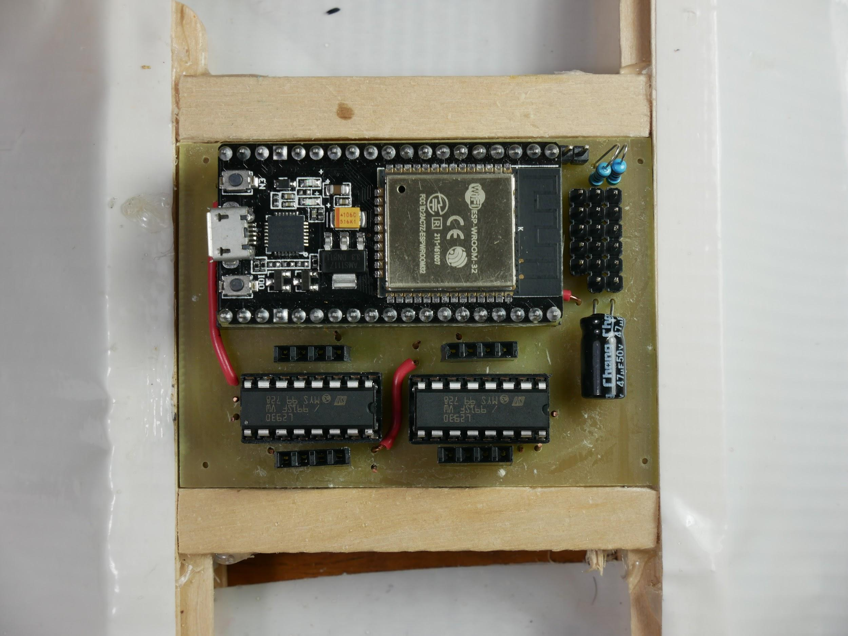

Top view of finished board

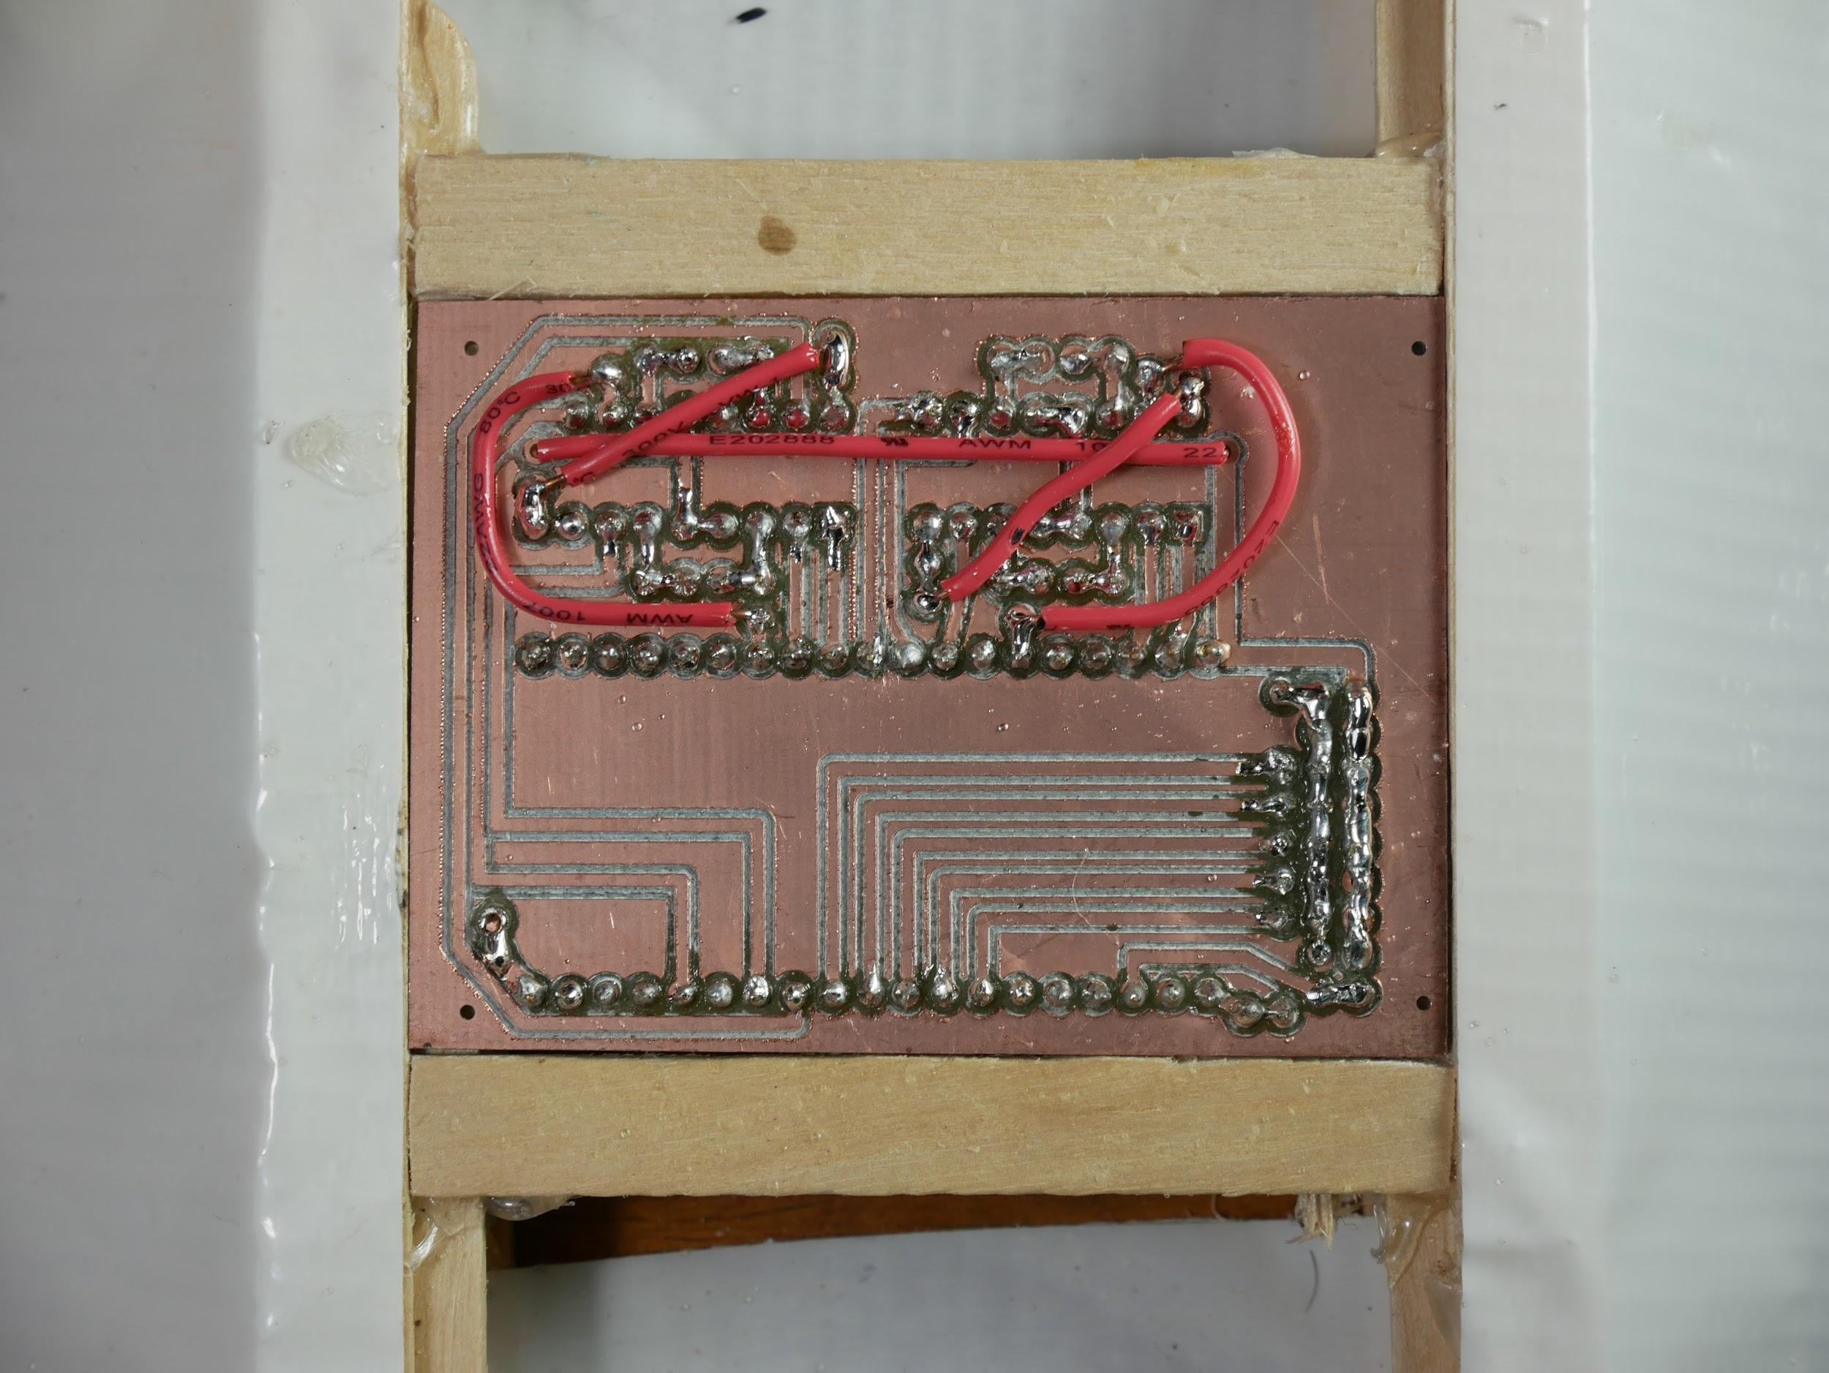

Bottom view of finished board (flipped like turning a page)

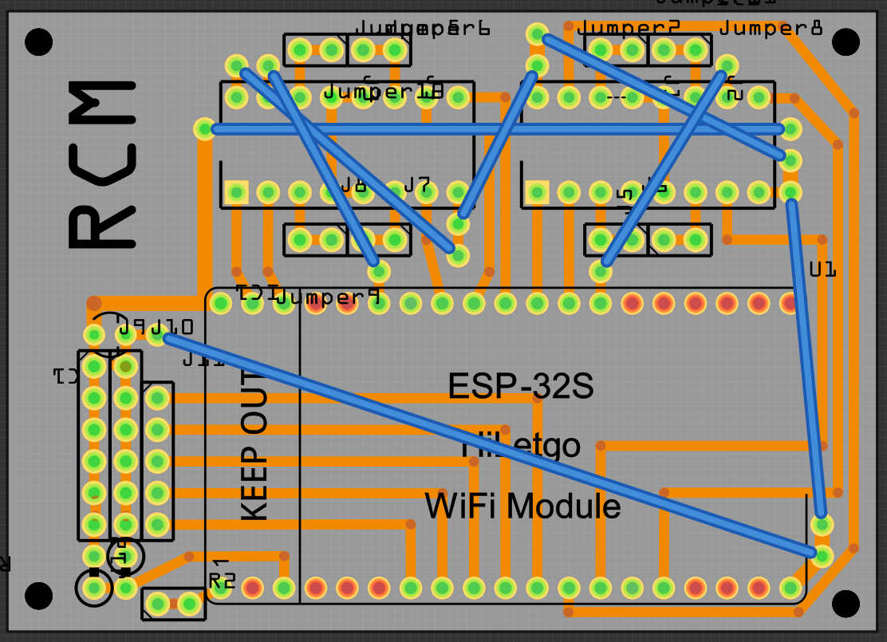

This picture shows the connections of the board. This is a top view of the board but shows the traces as if the board were see through.

# **Parts:**

1 NodeMCU ESP-32s, it should have 38 pins

2 L293D motor driver chip

1 custom circuit board

56 female header pins

19 male header pins

2 16 pin IC sockets

4ft wire (I used 22 gauge solid core)

1 5 AA bat holder

1 47uf capacitor

1 5 KΩ resistor

1 10 KΩ resistor

0-4 small 6v geared motors (<600 mA)

0-5 micro servo motors

5 rechargeable NiMH AA batteries

# **Tools:**

Soldering iron

Solder

Needle nose pliers

Wire strippers

Flush cutters

Sandpaper

Fume extractor fan

Tape

# **Custom Circuit Board:**

Here is the fritzing file for the board: <https://drive.google.com/open?id=1aipQb9t6Qfr8hrADWvjOZhG9OkPFuLrj>

When exporting for your router or circuit board service, make sure that the board will end up like in the photo below and not mirrored or with the traces on the wrong side of the board.

# **Build:**

Check the metal side of the board and make sure there are no shorts across traces or “stringy” bits of metal.

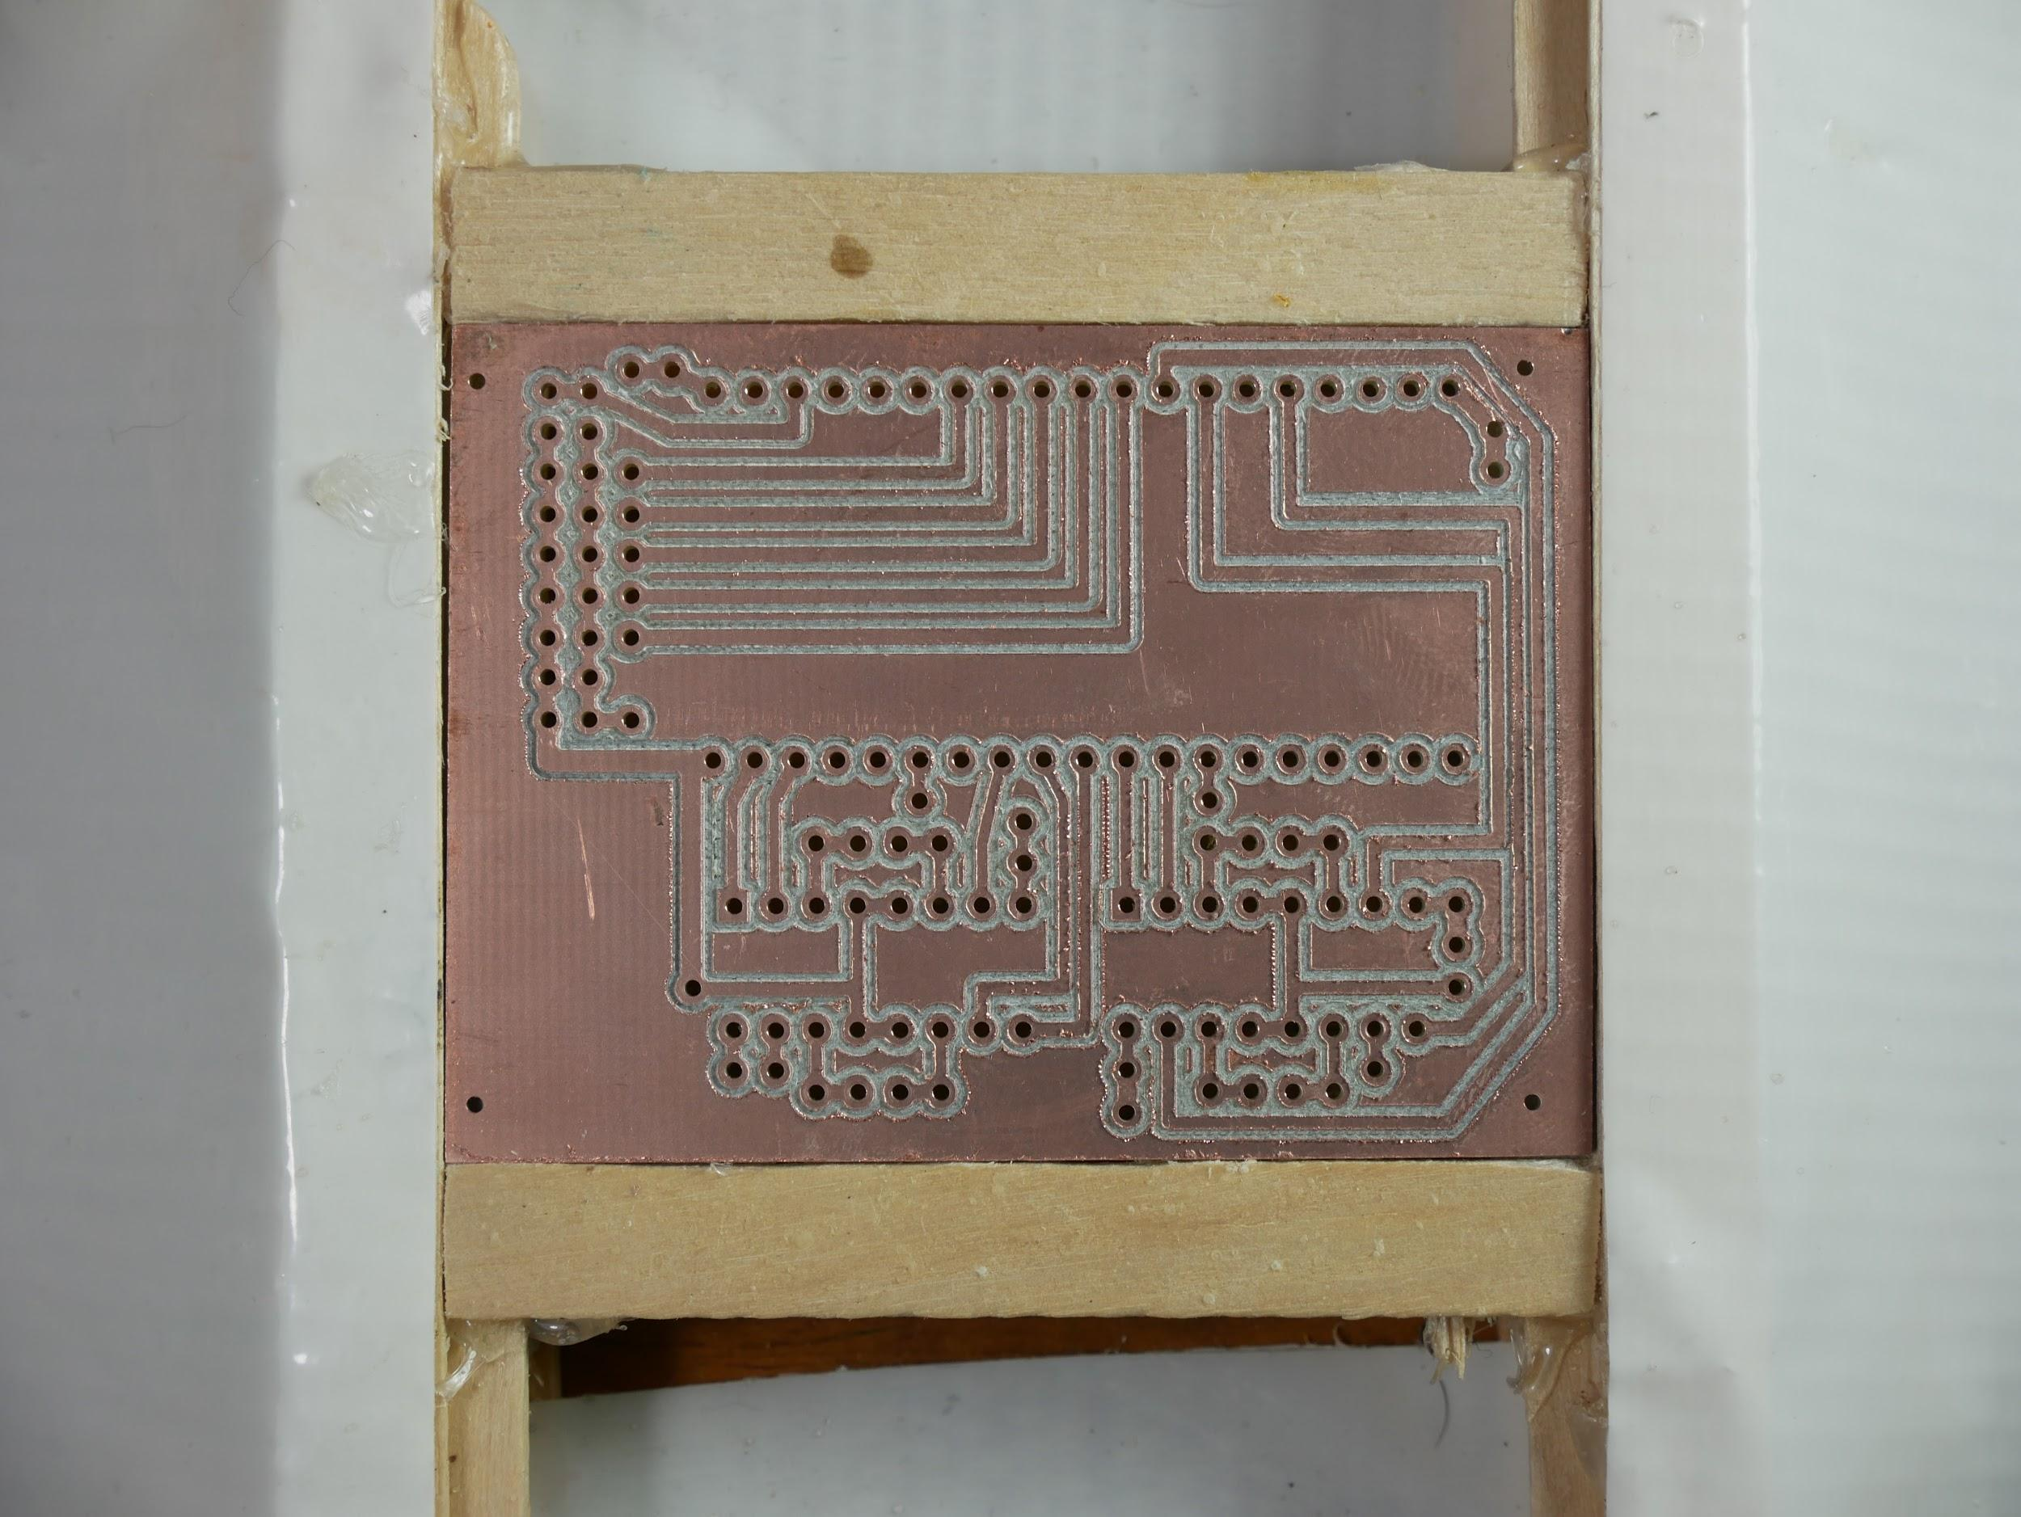

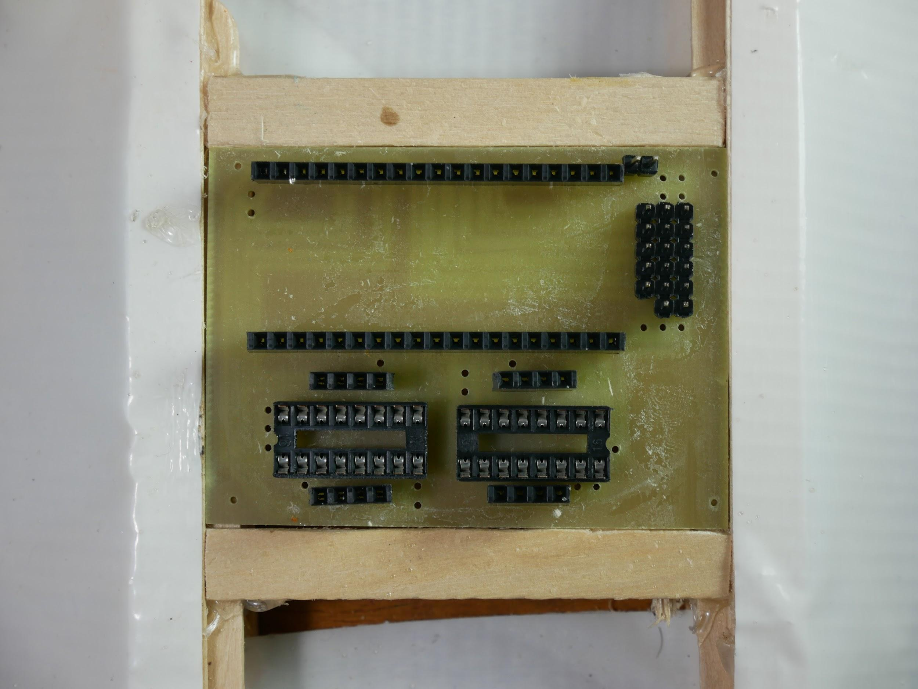

Place components in the board as shown.

*Use tape to secure each part to the board so it won’t fall out when you turn the board over to solder. Make sure everything stays at right angles to the board since if pins are soldered at an angle it will be hard to plug into them later.*

Solder every pin to the board.

*If two pins get bridged by solder that aren’t connected with a copper trace, you need to disconnect them (try melting the bridge with the soldering iron and “cutting” the blob with the tip of the iron.*

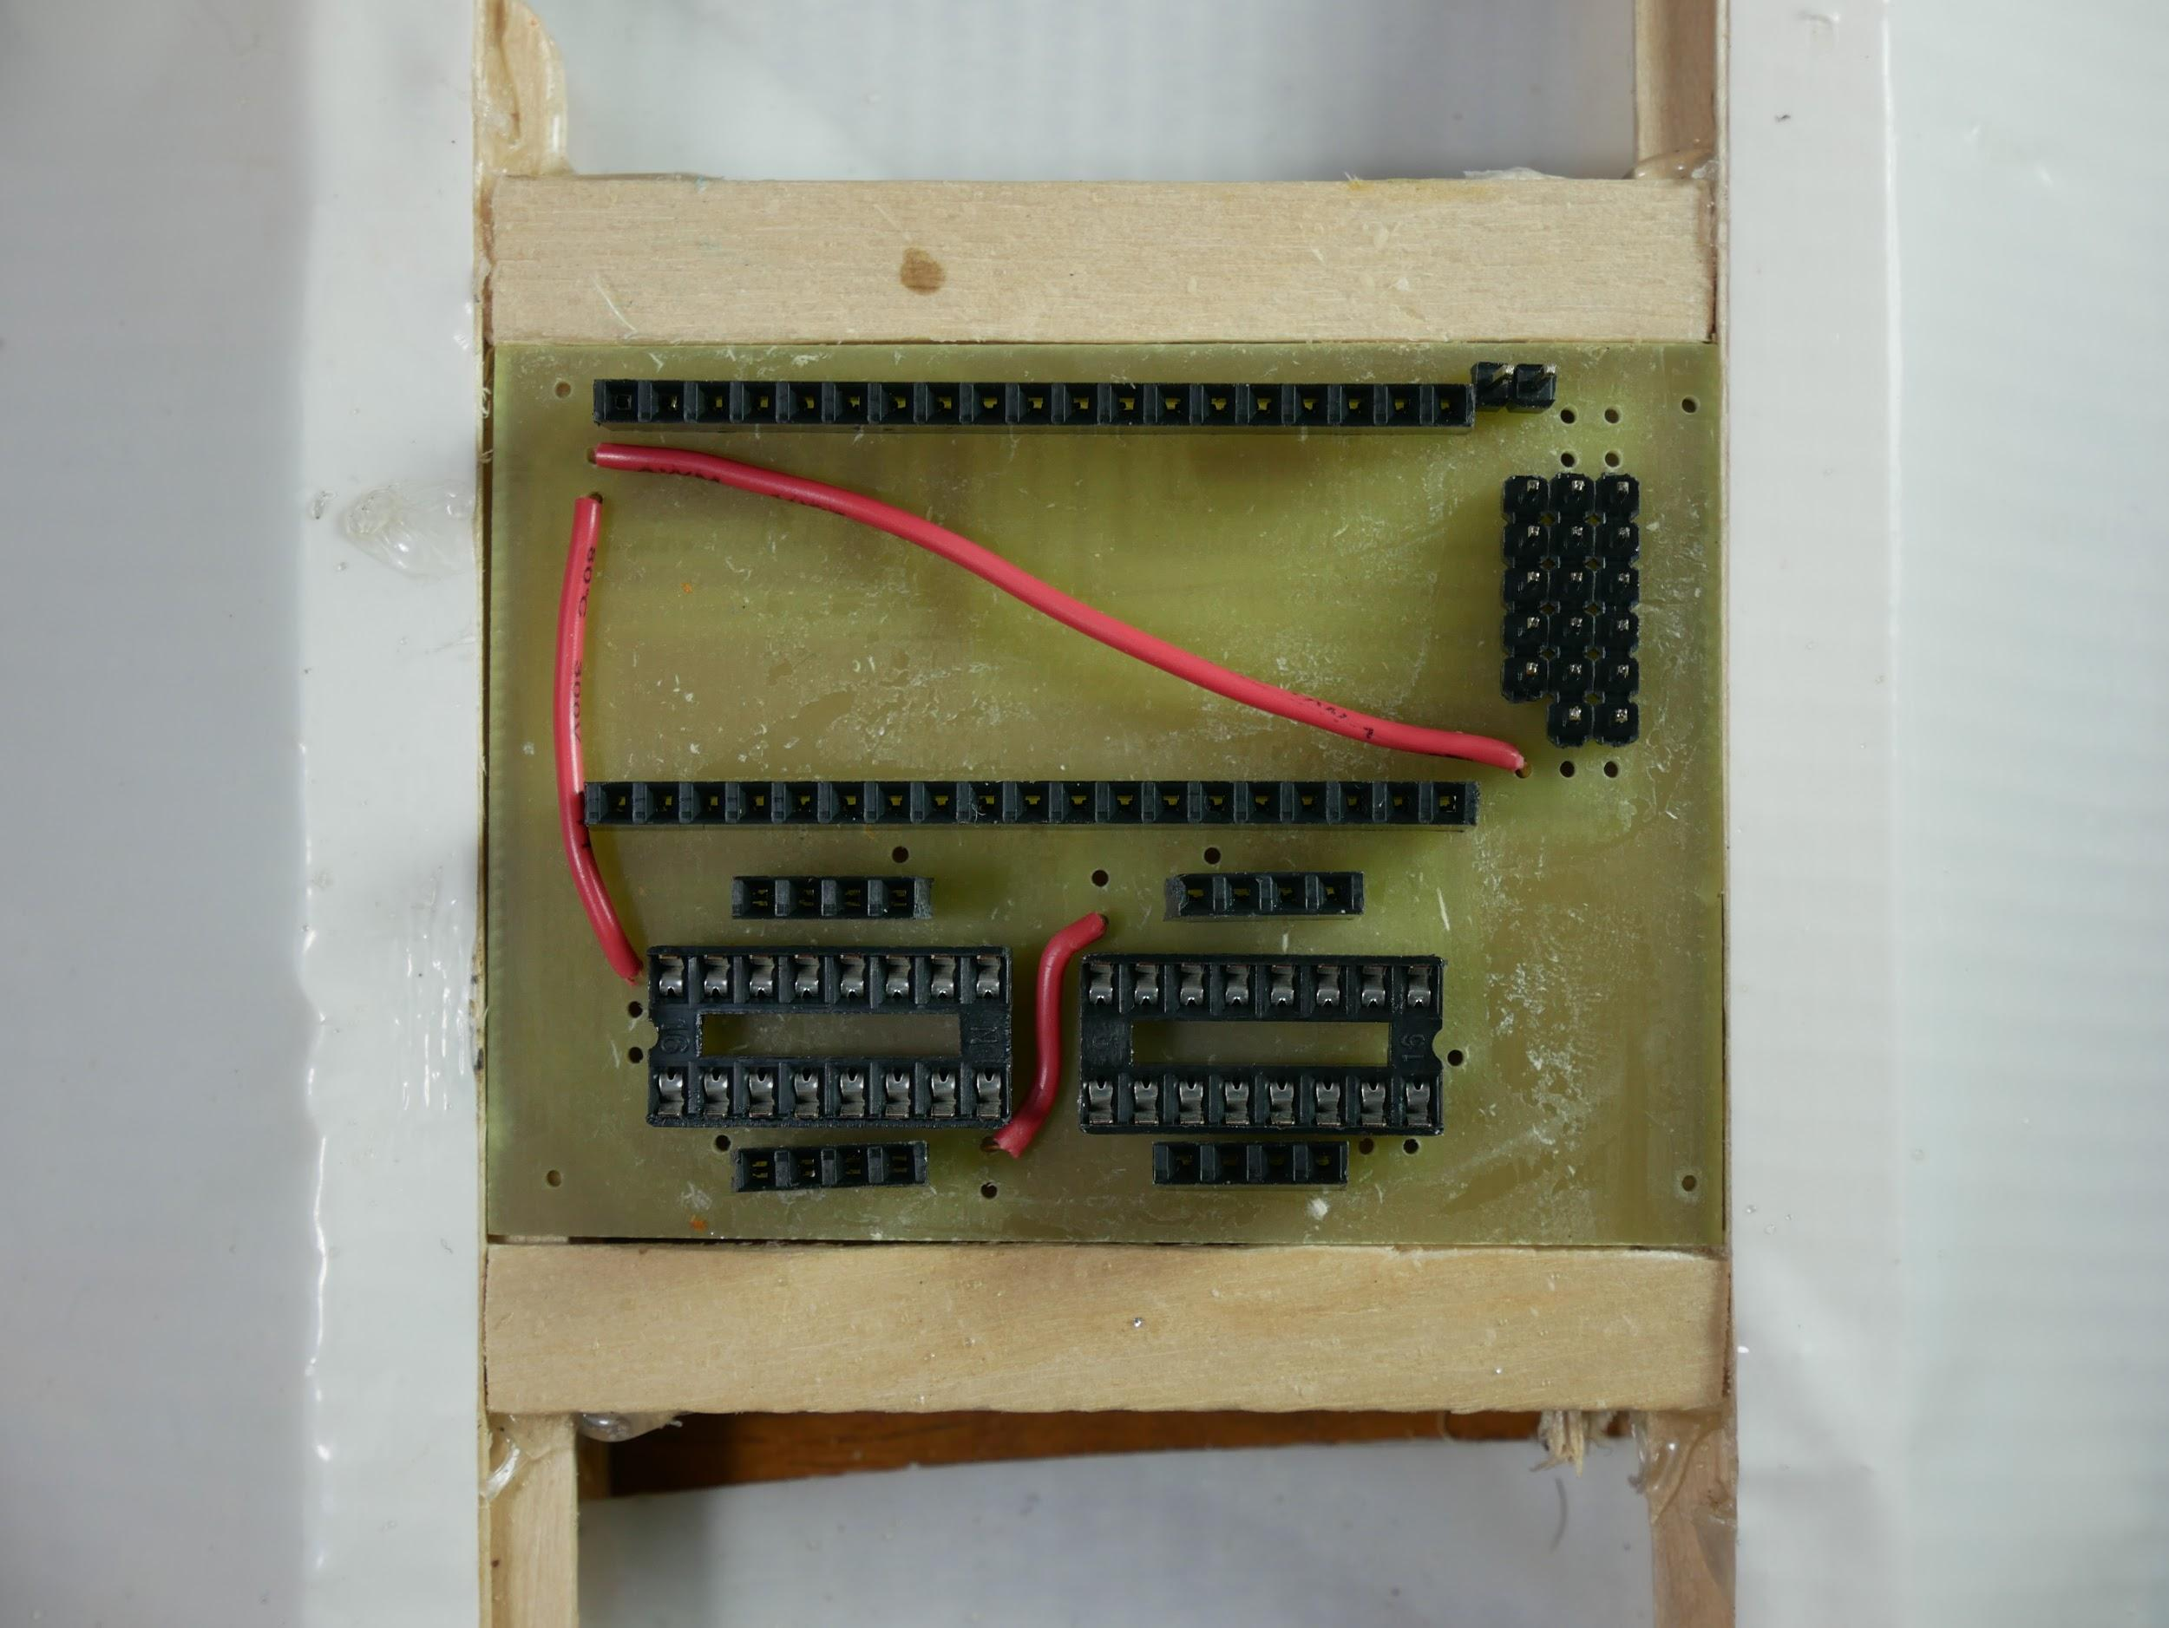

Add three wires to the top of the board as shown.

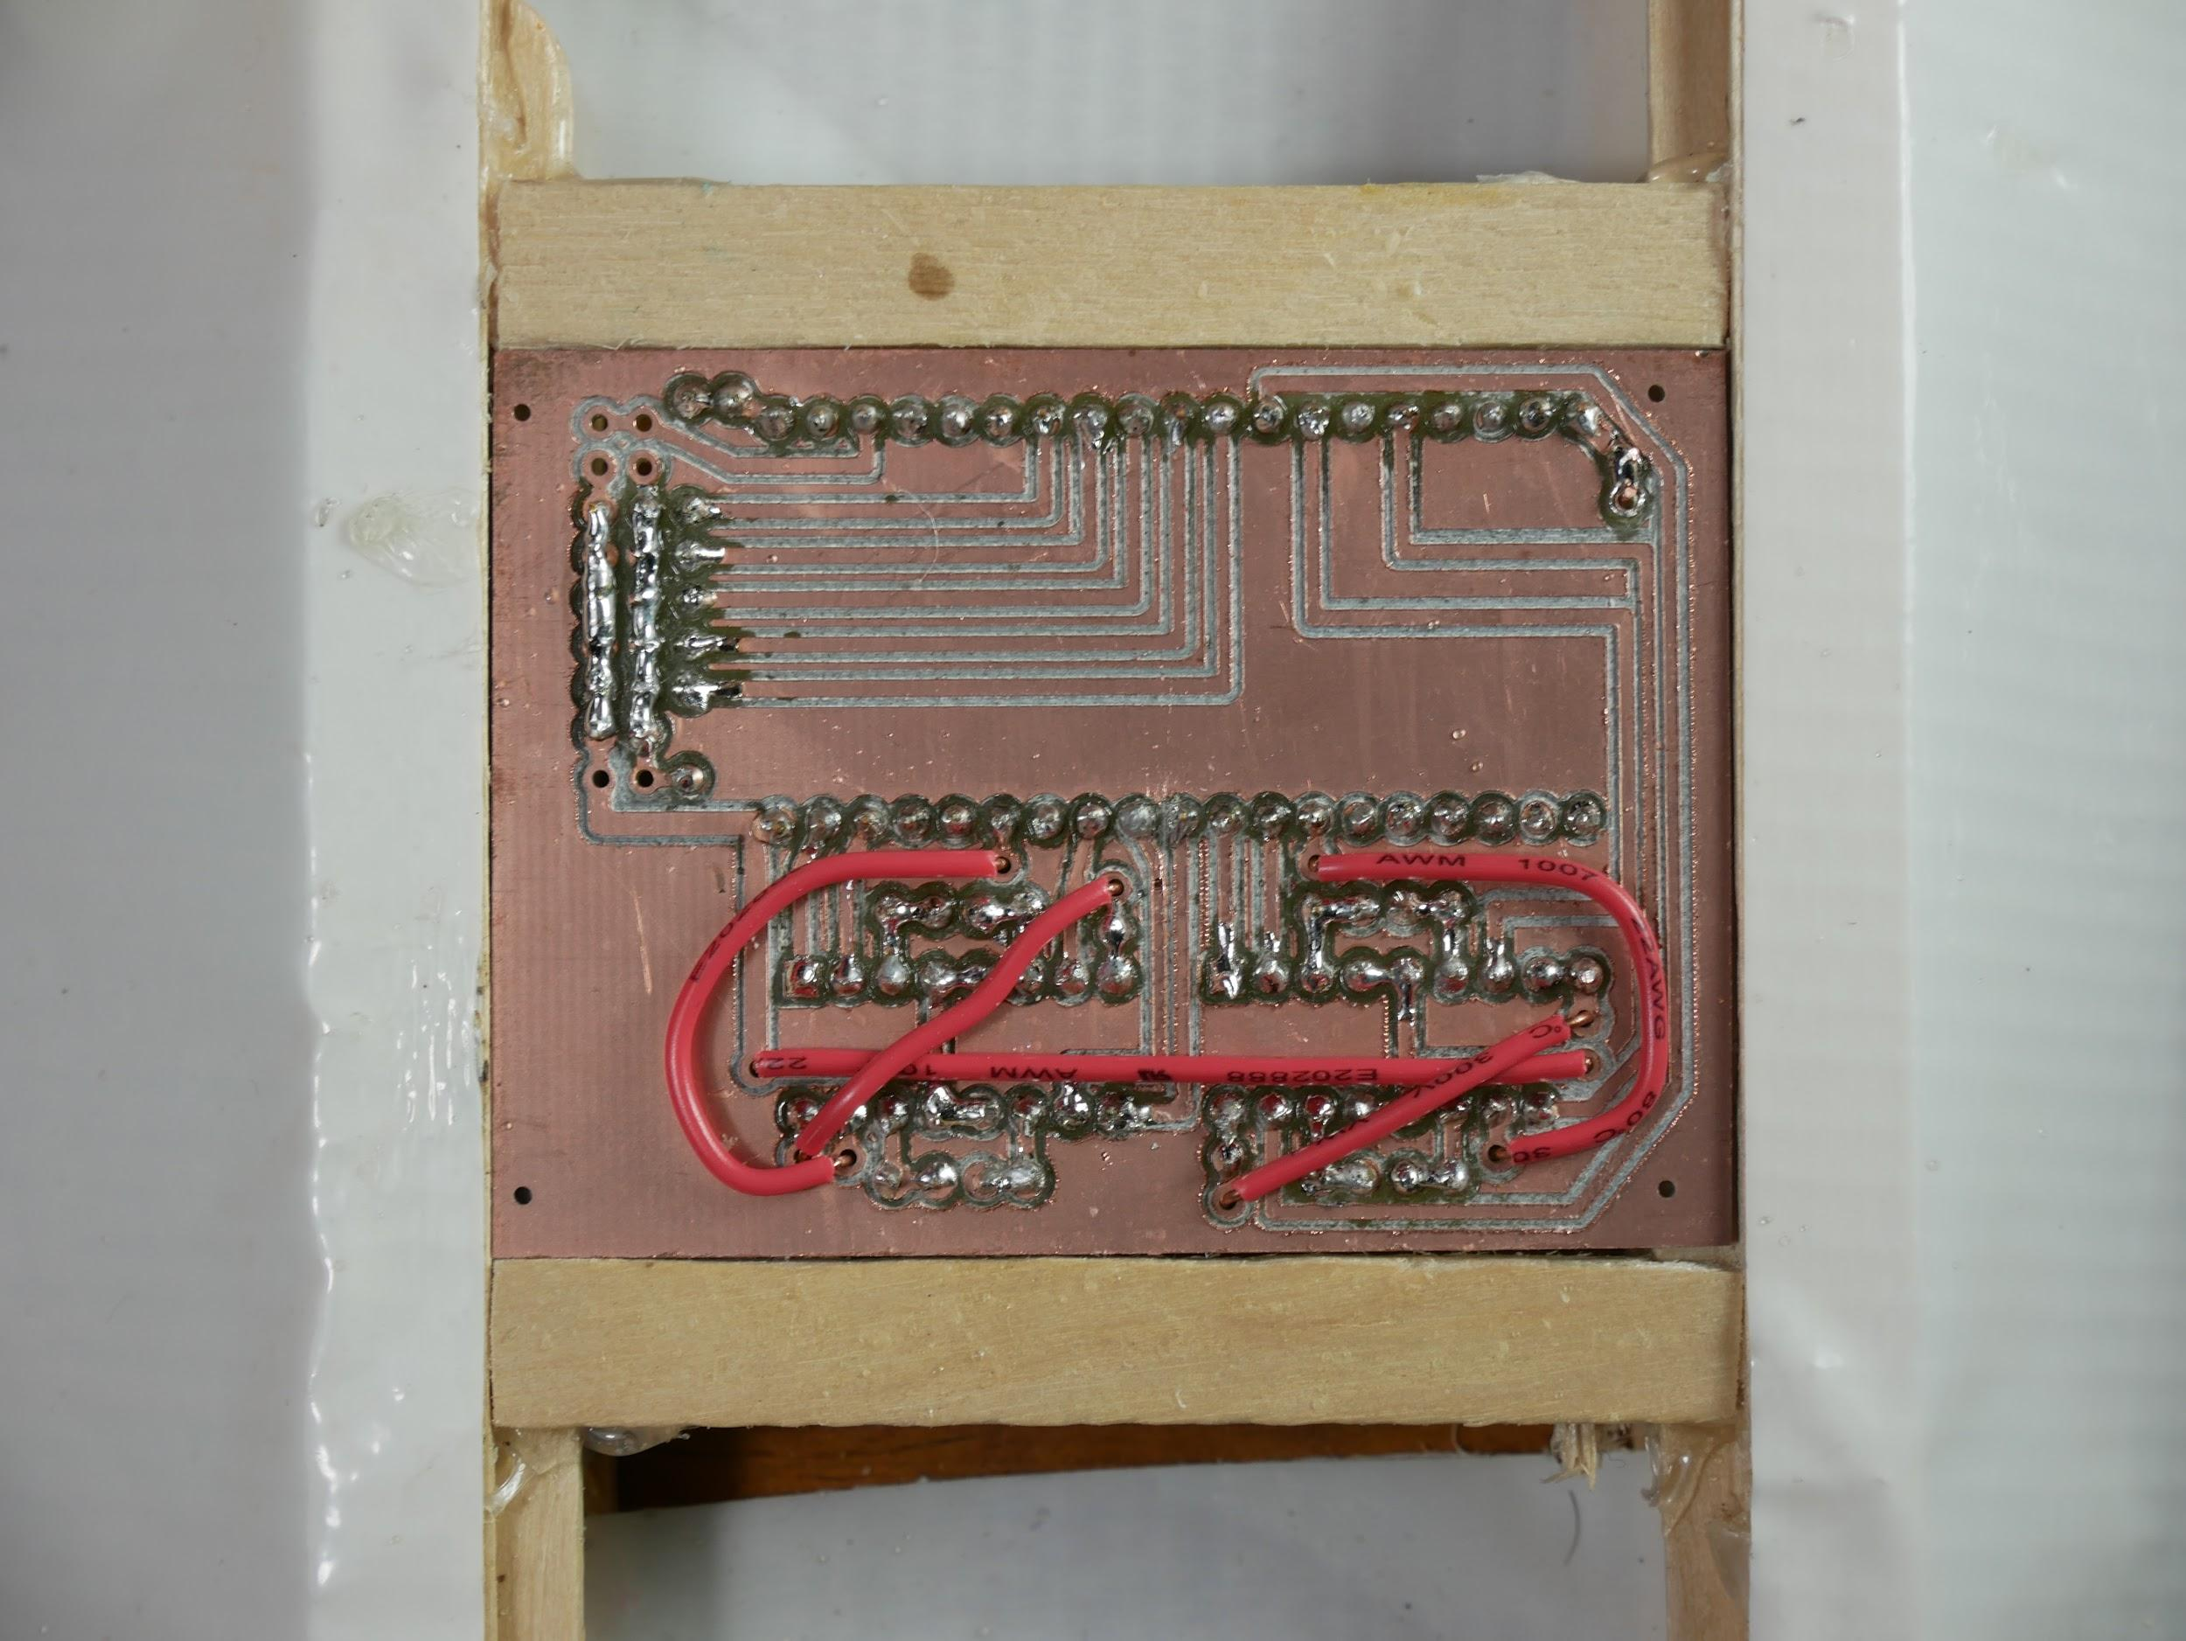

Add 5 wires to the bottom of the board as shown. Leave a little uninsulated wire out of the hole so you can add solder.

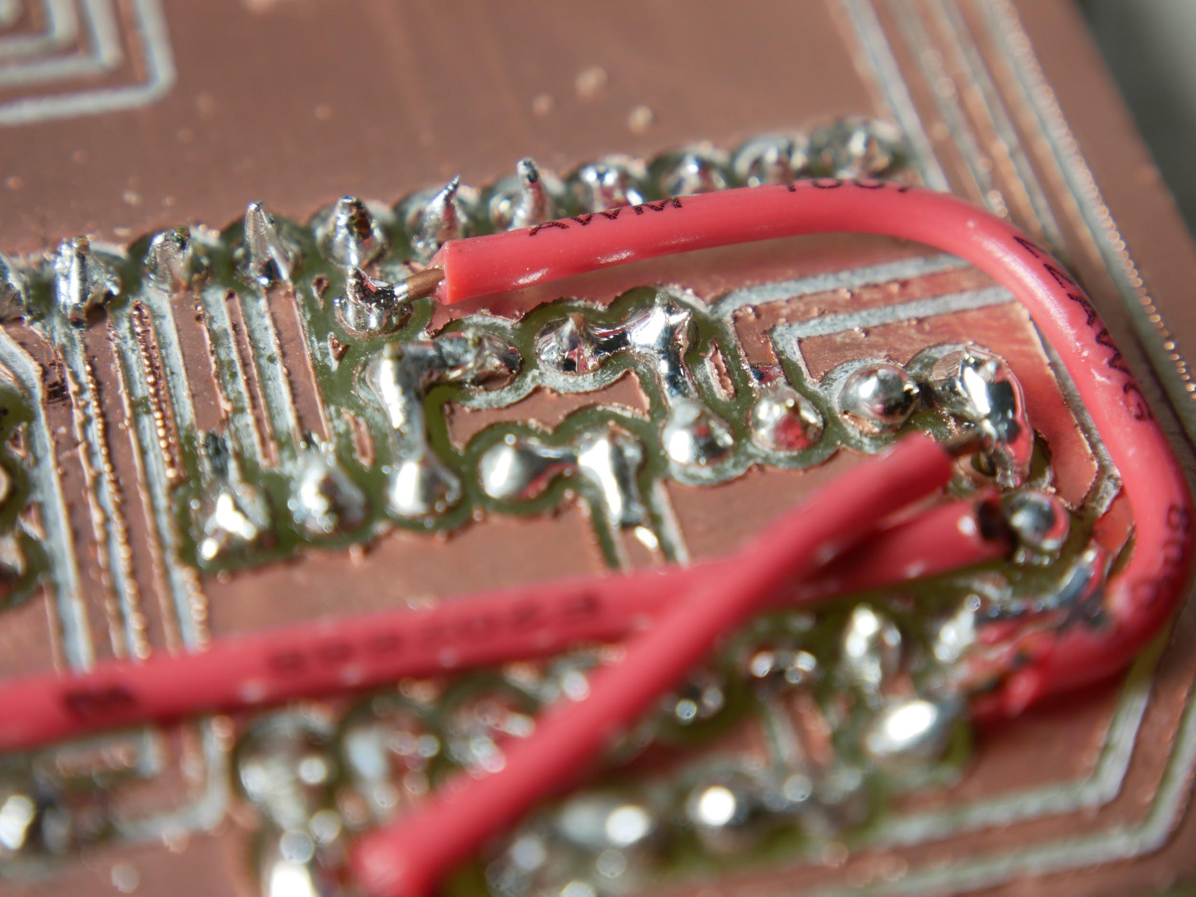

Solder all the wires in.

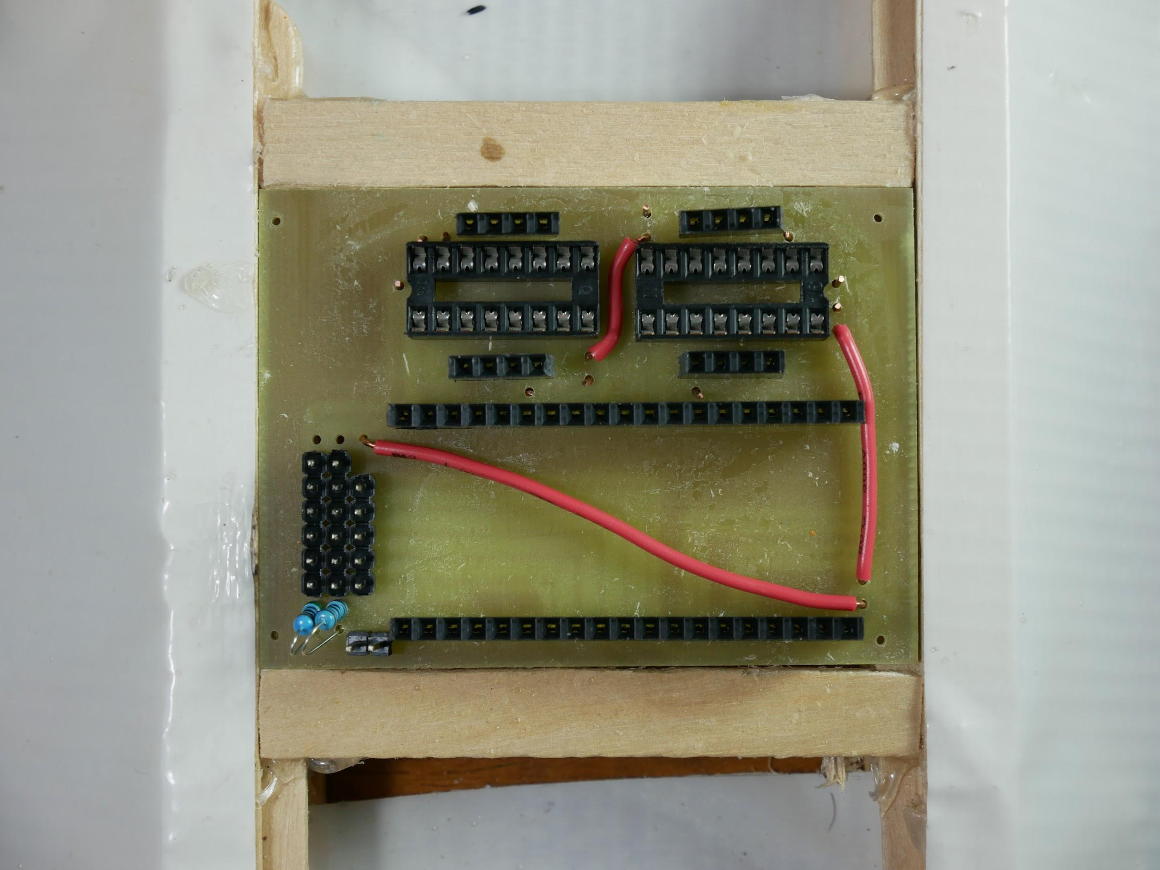

Solder the two resistors to the board as shown in the picture. The resistor on the left should be 5 KΩ and the one on the right should be 10 KΩ.

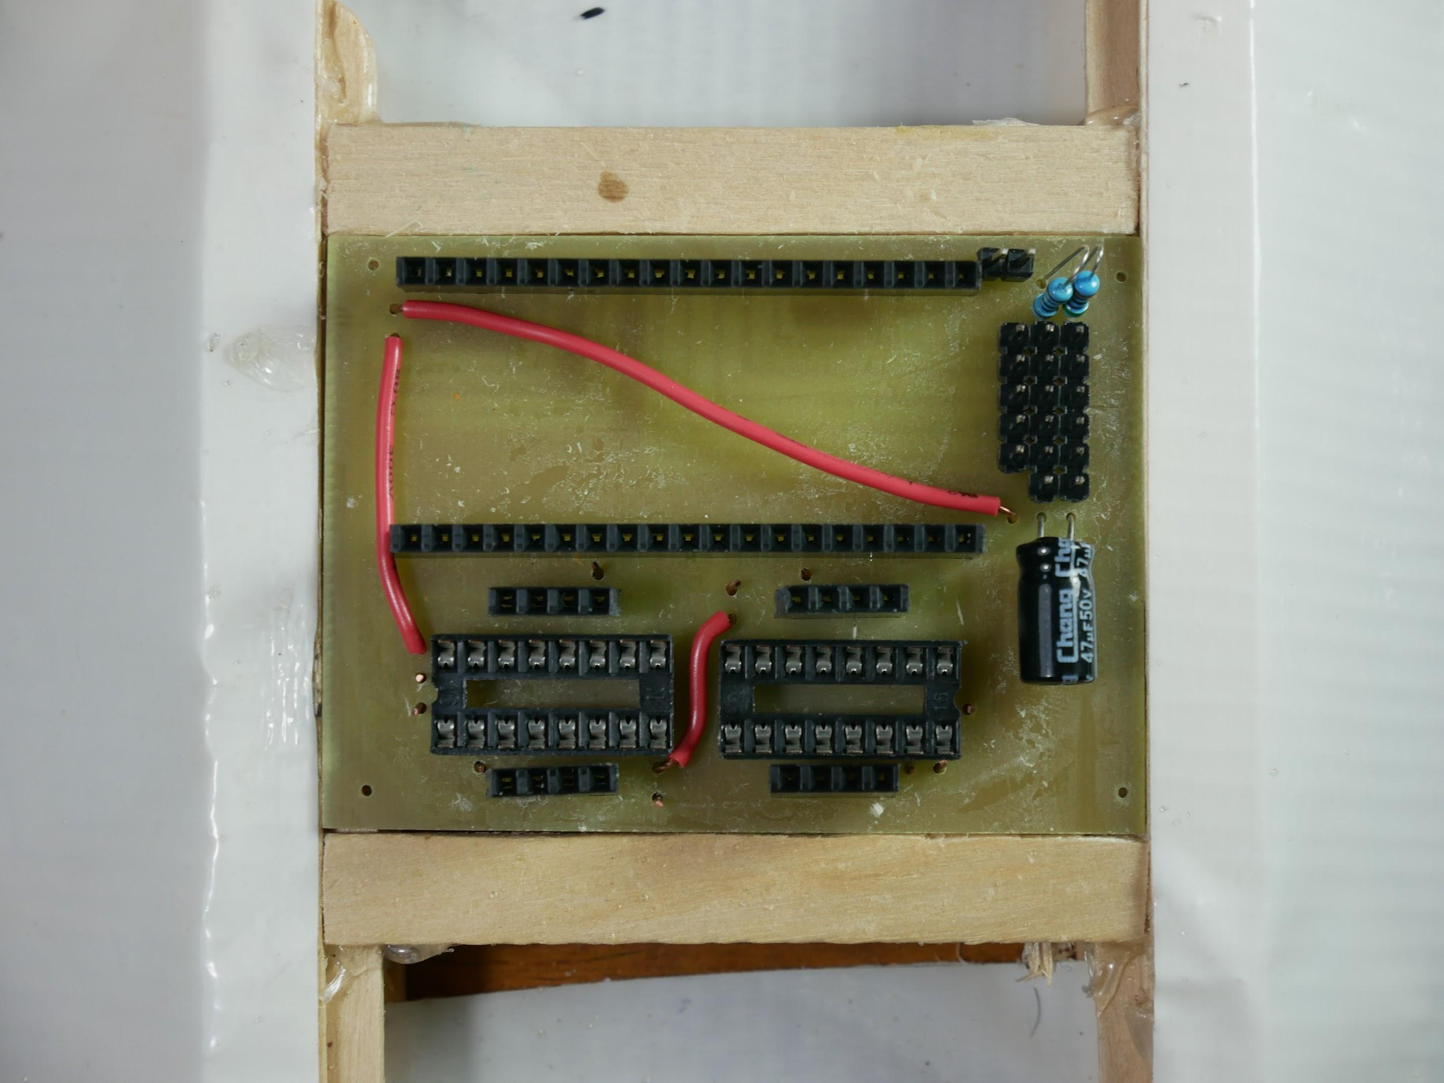

Solder the 47 uF capacitor to the board as shown in the picture. The negative wire of the capacitor (it’s on the side marked with a stripe, and it’s the shorter wire) needs to go in the left hole.

Trim any wires or pins that stick out too far from the board.



Add the ESP32 and the L293D chips. The orientation of the ESP32 should be as in the photo, the orientation of the driver chips doesn’t matter.

Add female pins to the battery pack wires.

Solder solid core wire or male headers to the motors so they can be plugged in.

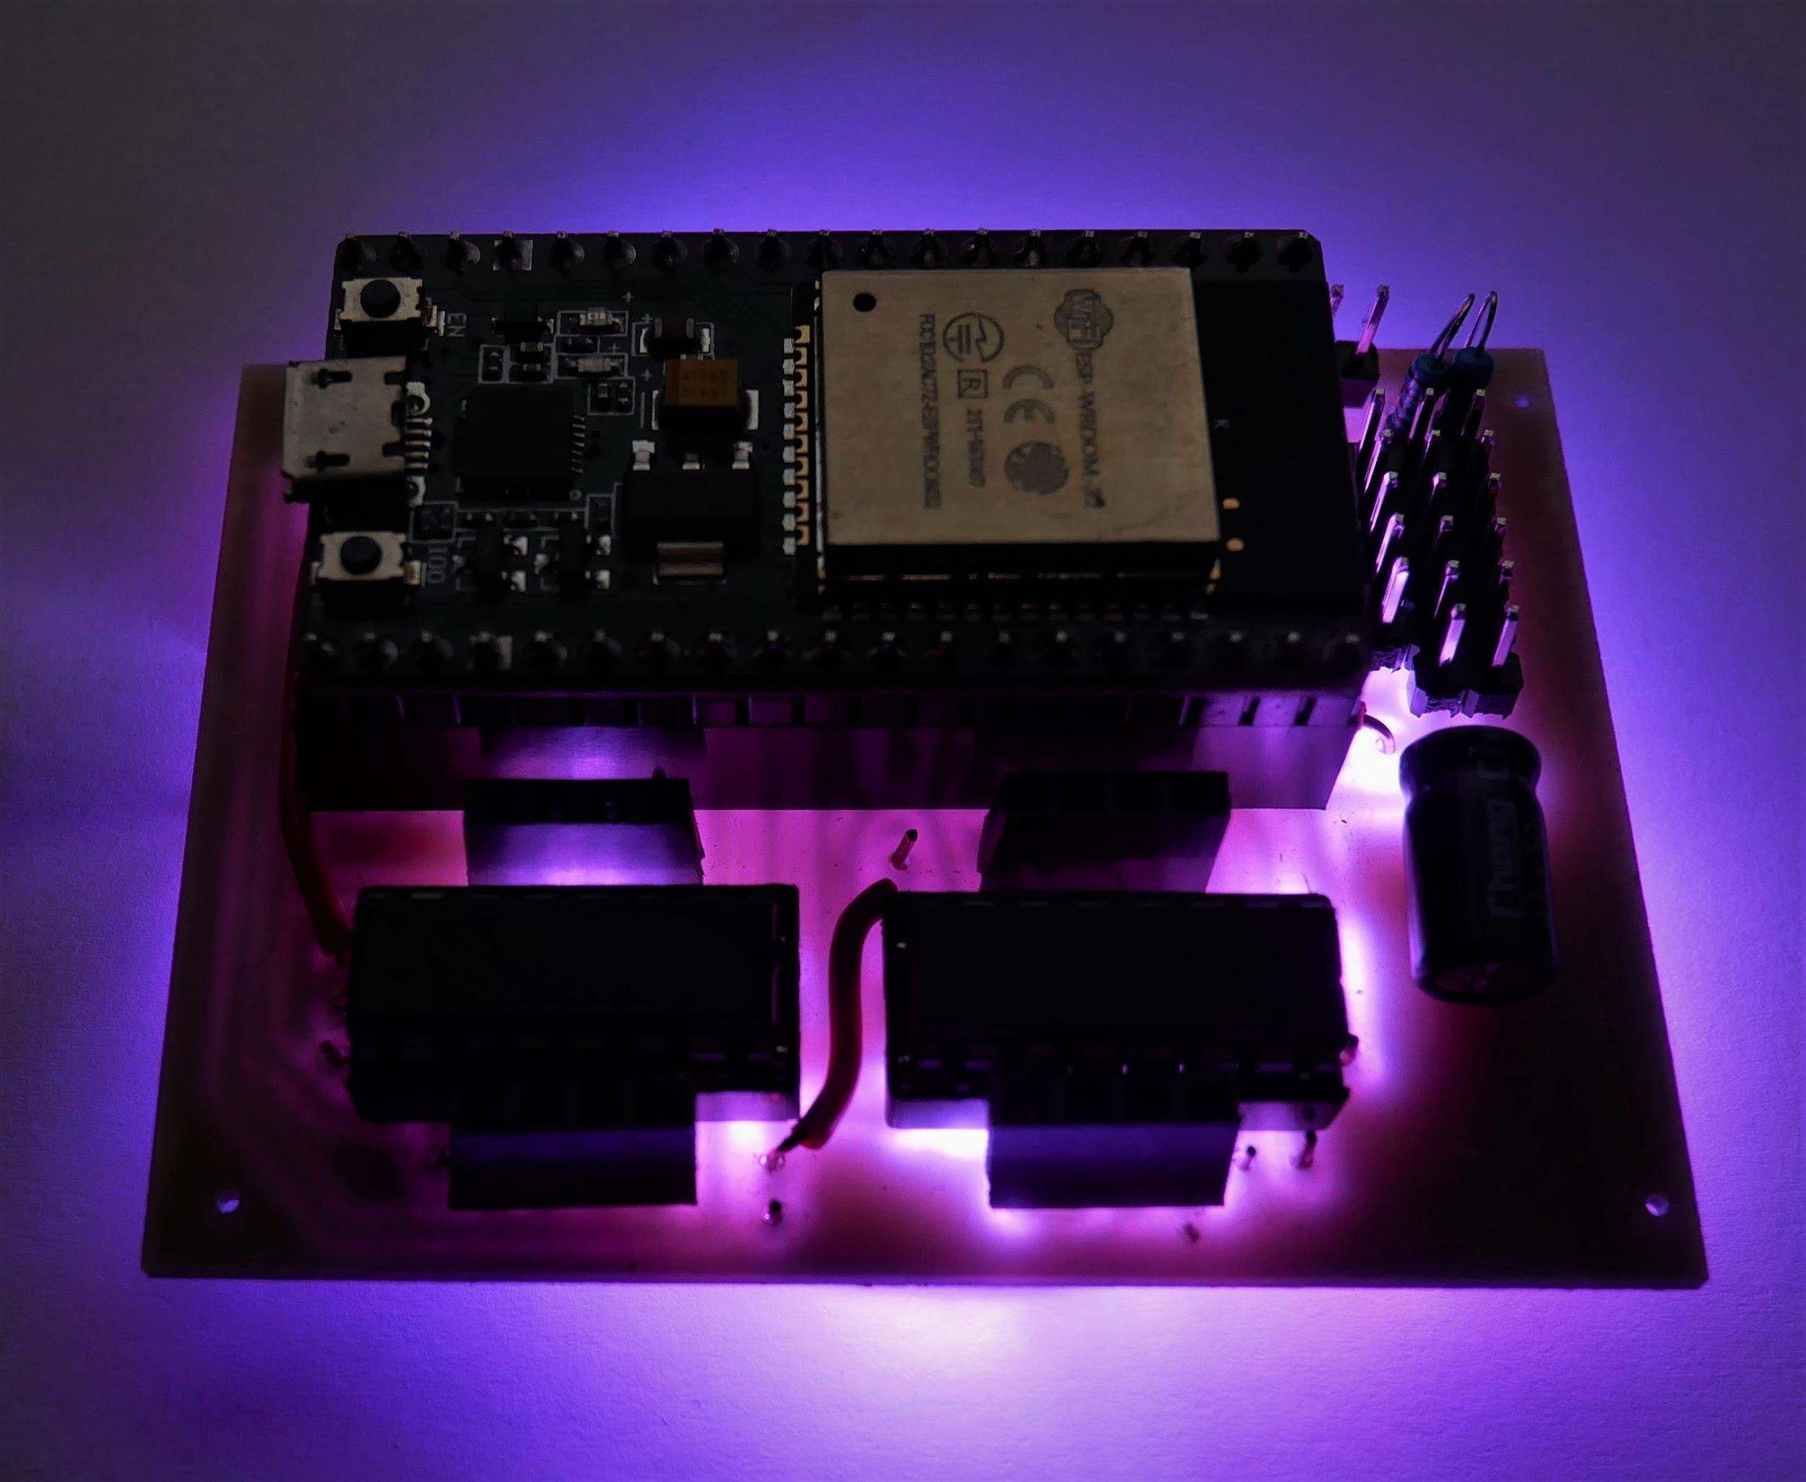

YOU’RE DONE BUILDING THE RCM!

# **Programming:**

## Upload Code to RCM:

<https://github.com/rcmgames/rcm>

## Install Driver Station App:

<https://github.com/rcmgames/RCMDS>

<https://github.com/rcmgames/RCMDS-new>

[RCM user guide](https://drive.google.com/open?id=12HUcpWKluF6-3oLMwZiLKZ4KrxwmTE_D)



When the board is oriented as shown in the picture above:

the motor ports are called:

portA portB

portC portD

(put one motor wire in one of the top two holes, one wire in one of the bottom two holes)

the servo ports are called:

port1 port2 port3 port4 port5

(plug servos in with ground at the top)

The power connection is to the right of the servo ports, ground is on top, +V is below that (don’t reverse).

The button to the right of the USB plug should be pressed when the Arduino IDE starts connecting to the esp32 or the upload will fail.

The button to the left of the USB plug restarts the code running on the esp32, you can try pressing it if you lose connection.